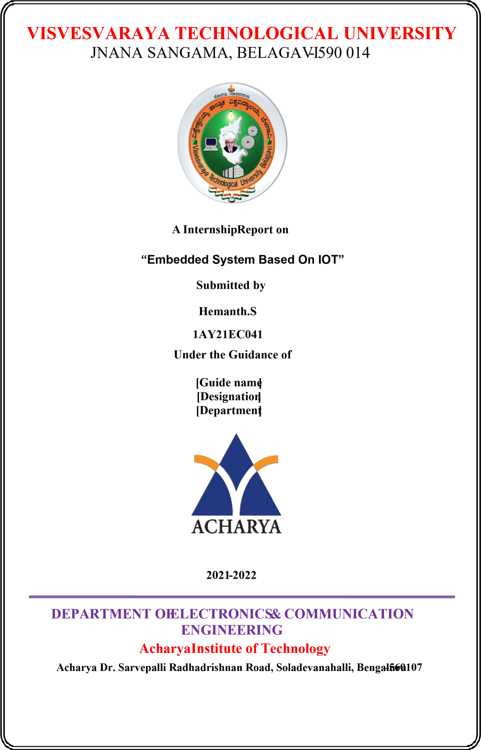

**ACHARYA INSTITUTE OF TECHNOLOGY**

**Hesaraghatta Road, Dr. Sarvepalli Radhakrishnan Road**

**Bengaluru 560107**

**DEPARTMENT OF ELECTRONICS AND COMMUNICATION**

**ENGINEERING.**



**CERTIFICATE**

Certified that the Internship entitled “Embedded system based on IOT”is carried out **by** Hemanth.S bearing USN 1AY21EC041 in the partial fulfillment for the award of degree of Bachelor of Engineering in **Electronics and Communication Engineering** of **Visvesvaraya Technological University**,

Belagavi during the year 2021-2022. It is certified that all corrections/suggestions indicated for the assessment have been incorporated in the report deposited in the departmental library. The Internship Report has been approved as it satisfies the academic requirement in respect of **Internship work**

**(21INT36)** prescribed for the Bachelor of Engineering Degree.

………………… ……………………

Signature of Guide Signature of HOD [Name and designation of Guide]

Dr. Rajeswari  Prof and Head of the Dept. Dept. of ECE, AIT

## 

**ACHARYA INSTITUTE OF TECHNOLOGY**

**Hesaraghatta Road, Dr. Sarvepalli Radhakrishnan Road**  **Bengaluru**

**560107**

**DEPARTMENT OF ELECTRONICS AND COMMUNICATION**

**ENGINEERING.**



2021-2022

**DECLARATION**

I, Hemanth.S, 1AY21EC041, hereby declare that the Internship work entitled **“Embedded system based on IOT”** has been independently carried out by me under the supervision of

[Guide’s name and designation], Department of Electronics and Communication Engineering, Acharya Institute of Technology in partial fulfilment of the requirement for the award of the degree of **Bachelor of Engineering** in **Electronics and Communication Engineering** by **Visvesvaraya Technological University, Belagavi** during the year **2020-21.**

**Place: Bangalore HEMANTH.S**

**Date:31/10/2021 1AY21EC041**

**ACKNOWLEDGEMENT**

## 

The satisfaction and euphoria that accompany the successful completion of a task would be incomplete without the mention of the people who made it possible and without their constant guidance and encouragement, success would not have been possible.

I am grateful to the institute **Acharya Institute of Technology** and management with its ideas and inspiration for having provided us with the good infrastructure, laboratory, facilities and inspiring staff which has made this seminar report complete successfully.

I would like to express my sincere gratitude to **Dr. Rajath Hegde M M, AIT** for all the facilities that he has extended throughout my work.

I heartily thank and express my sincere gratitude to **Dr. Rajeswari, Professor and HOD, Dept. of ECE, AIT** for her valuable support and a constant source of enthusiastic inspiration to steer us forward.

I would like to express my sincere gratitude to the Internal Guide **Mrs. XXXXX, Assistant Professor, Dept. of ECE, AIT** for her invaluable guidance and support.

I would like to express my sincere gratitude to the Internship Coordinators **XXXXX, Assistant Professor, Dept. of ECE, AIT** for her valuable guidance and support.

Finally, I would like to express my sincere gratitude to my parents, all teaching and nonteaching faculty members and friends for their moral support, encouragement and help throughout the completion of the Technical Seminar.

**“HEMANTH.S”**

**1AY21EC041**

**ABSTRACT**

IOT is the trendiest field in the research area. IOT deals with the creation of smart devices that makes number of tasks for the person easier. The smart devices are created using embedded systems. Embedded systems are the mini computers that allow the sensor devices to work in a collaborative manner to create an electronic system. This study discusses the role of embedded systems, and the different components of the embedded system. Moreover, the study discusses the three types of the most popular embedded system that is Arduino, Raspberry Pi and Node

MCU.

When it comes to developing embedded IoT devices, the hardware design is viewed as a critical component for the successes of the IoT product. In order to ensure the embedded IoT product meets the required function, consumes low power and is secure and reliable, a lot of challenges are faced by the embedded IoT device manufacturers during the hardware designing phase of these devices. With the advent of the internet of things or IoT, there has been a massive growth of the embedded systems market due to the speedy development of the connected devices. The embedded intelligent connectivity continues to increase at a phenomenal rate as a result of the Internet of things.

Contents

CHAPTER 1 1

INTRODUCTION 1

CHAPTER 2 3

TOOLS AND TECHNOLOGIES REQUIREMENTS: 3

Software Requirements 3

Hardware requirements: 5

CHAPTER 3 15

LEARNING OUTCOMES 15

CHAPTER 4 21

CONTRIBUTIONS WITH RESULTS AND DISCUSSIONS 21

CHAPTER 5 22

SUMMARY 22

CHAPTER 6 23

REFERENCES 23

Figure 1 Google Colab 3

Figure 2 - TinkerCad 3

Figure 3-Arduino IDE 4

Figure 4-Putty 4

Figure 5- VNC Viewer 5

Figure 6-LED 5

Figure 7- Resistor 6

Figure 8- Buzzer 6

Figure 9- Jumper Wire 7

Figure 10- Bread Board 8

Figure 11- Ultra-Sonic Sensor 8

Figure 12- IR Sensor 9

Figure 13- I2C Module 10

Figure 14- Potentiometer 10

Figure 15- Raspberry Pi 14

# CHAPTER 1

## INTRODUCTION

An embedded system is a computer system designed to perform a variety of tasks, such as accessing, processing, storing, and controlling data in various electronic systems. An embedded system are a combination of hardware and software where the software is usually known as firmware that is embedded into the hardware. One of the most important features of these platform is that they manage time. So, we usually use embedded system in simple and complex devices too. The applications of embedded systems mainly involve in our real life for several devices like microwave, calculator, TV remote control, home security and neighborhood traffic control systems.

An embedded system uses a hardware platform to perform the operation that are required. Hardware of the embedded system is assembled with a microprocessor/microcontroller [.It](https://www.elprocus.com/microprocessor-and-microcontroller/) has the elements such as input/output interfaces, memory, user interface and the display unit. Generally, an embedded system consists of the f[ollowing.](https://www.elprocus.com/microprocessor-and-microcontroller/)

* [Power supply](https://www.elprocus.com/switch-mode-power-supply-working/)
* Memory
* Processor
* Timers
* Output/output circuits
* Serial communication ports
* SASC (system application specific circuits)

The [software of an embedded system is written to e](https://www.elprocus.com/embedded-system-programming-using-keil-c-language/)xecute a particular function. It is normally written in a high-level setup and then compiled down to offer code that can be stuck within a non-volatile memory in the hardware.

RTOS (real time operating system):

A system that is important to perform its tasks and provide services on time is simply called a real-time operating system. The RTOS system controls the application software and provides the processor with the necessary equipment for its operation. It is responsible for managing the different hardware resources of the personal computer and hosting the applications which run on the PC.

Memory and processors:

The different kinds of processors used in an embedded system include digital signal processor (DSP), microprocessor, [RISC PROCESSOR, mic](https://www.elprocus.com/what-is-risc-and-cisc-architecture-and-their-workings/)rocontroller, ASSP processor, ASIP processor, and arm processor.

Embedded systems have become an essential part of all modern electronic components, such as microwave ovens, washing machines, remote controls, RFID tags, routers, modems, PDAS, mobile phones and more. An embedded system is a part of a larger machine that performs a specific task. For example, they are used as integrated home automation systems to control lights, sensors, smart climate change, audio-visual systems and more.

Today, the Internet of Things is one of the hot topics in the industry and has taken its place in traditional business terminology. However, this presents some challenges for developers: They need to design devices that allow for seamless connectivity.

With the growth and advancements in electronics and wireless communication, the devices around us can be better than anyone can imagine. The future of embedded systems and IoT lies in the advancement of technologies that enable faster communication with highly interconnected connections between different devices. IOT is gradually entering our lives and is expected to become more interesting in the future. It will be more than just a concept and interoperability between embedded devices will revolutionize the way data and devices are connected.

Embedded systems are standalone devices that have usually been designed to do one specific thing. An IoT embedded system is an embedded system that also has connectivity to the internet and can therefore communicate with other IoT embedded systems.

We are surrounded by IoT embedded systems such as:

Set-top boxes

Point of Sale (POS) terminals

A wide variety of medical devices

Any "smart" devices such as smart refrigerators, smart bicycles, fitness trackers, etc.

Parking meters and soon.

An embedded system for IoT will have some type of software installed on it to allow it to perform its function. This could be simply firmware or an embedded operating system. It is the software that empowers the IoT embedded system to communicate with other IoT embedded system devices. An embedded device is a highly specialized device intended for one or very few specific purposes. It is also called a Single Purpose Device or Dedicated Device. These devices are IoT embedded systems that have been created specifically to operate one program or perform a task that is specific to a certain type of business.

# CHAPTER 2

## TOOLS AND TECHNOLOGIES REQUIREMENTS:

## 

### Software Requirements

1. Google Colab:

Colab is a free Jupyter notebook environment that runs entirely in the cloud. Best of all, it requires no setup, and your teammates can edit the notebooks you create at the same time, just like you would Google Docs. Colab supports many popular machine learning libraries that can be easily downloaded to your laptop.



Figure 1 Google Colab

2.Tinker CAB:

The circuit part of Tinker cad is an electronic circuit simulator with an Arduino Uno board, Micro Bit, or an AT tiny chip in a browser. Code can be generated using Code Blocks, which are graphical pieces of code that can be grouped together by moving the mouse pointer. It is also possible to program using code script. They call Tinker CAD "intuitive". Circuits can be built from components, but there are "starters", which are circuits with code.

The Tinker CAD includes libraries for components such as the Adafruit Neo Pixel library, the Arduino Servo library, and the I2C display library. Additional libraries cannot be selected or downloaded. The circuit may contain fully simulated analog components.

Figure 2 - TinkerCad

3.Arduino IDE:

The Arduino integrated development environment, or Arduino software (IDE), contains a text editor for writing code, a message area, a text console, a toolbar with buttons for common functions, and a sequential menu. Connects to Arduino devices to download and communicate with software.



Figure 3-Arduino IDE

4. Putty:

PUTTY is a free and open source terminal emulator, serial console, and network file transfer application. It supports many network protocols, including SCP, SSH, Telnet, rlogin, and raw socket connections. It can also be connected to a serial port. The name "PuTTY" has no official meaning. PuTTY was originally written for Microsoft Windows, but has been ported to many other operating systems. Official ports are available for some Unix-like platforms, ports work for classic Mac OS and macOS, unofficial ports are also added for platforms like Symbian, Windows Mobile and Windows Phone.

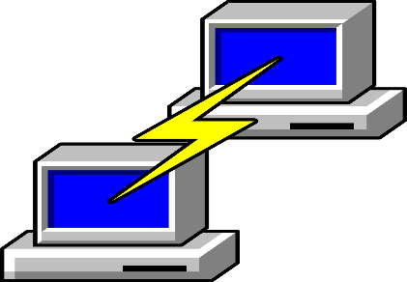

Figure 4-Putty

5.VNC Viewer:

VNC stands for Virtual Network Computing. It is a cross-platform screen sharing system designed to remotely control another computer. This means that remote users can control the computer's monitor, keyboard and mouse remotely from an additional device as if they were sitting right in front of it. It can be a computer, a tablet or another phone.



Figure 5- VNC Viewer

## Hardware requirements:

1. LED:

A light-emitting diode (LED) is a semiconductor device that emits light when current flows through it. Electrons in the semiconductor recombine with electron holes, releasing energy in the form of photons. The colour of the light (corresponding to the energy of the photons) is determined by the energy required for electrons to cross the band gap of the semiconductor.

LEDs have many advantages over incandescent light sources, including lower power consumption, longer lifetime, improved physical robustness, smaller size, and faster switching. In exchange for these generally favourable attributes, disadvantages of LEDs include electrical limitations to low voltage and generally to DC (not AC) power, inability to provide steady illumination from a pulsing DC or an AC electrical supply source, and lesser maximum operating temperature and storage temperature.

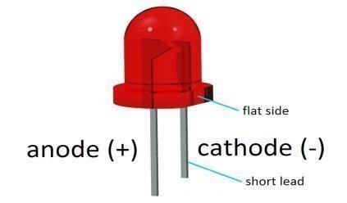

Figure 6-LED

2. Resistor:

A resistor is a passive electrical component that implements resistance as a circuit element at both ends. In electronic circuits, resistors are used to reduce current flow, adjust signal levels, divide voltages, bias active components, terminate transmission lines, and more. The resistance of a stator resistor changes only slightly with temperature, time, or operating voltage.

Resistors are common components in electrical networks and electronic circuits and are ubiquitous in electronic devices. Practical resistors as separate components can consist of various connections and shapes. Resistors are also implemented in integrated circuits.

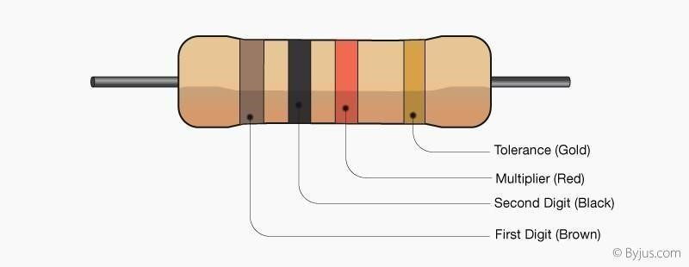

Figure 7- Resistor

3. Buzzer:

An audio signalling device like a beeper or buzzer may be electromechanical or [piezoelectric](https://www.elprocus.com/what-is-a-piezoelectric-material-working/) or mechanical type. The main function of this is to convert the signal from audio to sound. Generally, it is powered through DC voltage and used in timers, alarm devices, printers, alarms, computers, etc. Based on the various designs, it can generate different sounds like alarm, music, bell & siren.

The working principle of a buzzer depends on the theory that, once the voltage is given across a piezoelectric material, then a pressure difference is produced. A piezo type includes piezo crystals among two conductors.

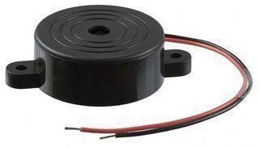

Figure 8- Buzzer

4.Jumper wire:

Jumper wires are simply wires that have connector pins at each end, allowing them to be used to connect two points to each other without soldering. Jumper wires are typically used with breadboards and other prototyping tools in order to make it easy to change a circuit as needed. Fairly simple. In fact, it does not get much more basic than jumper wires. Though jumper wires come in a variety of colours, the colours do not actually mean anything. This means that a red jumper wire is technically the same as a black one. But the colours can be used to your advantage to differentiate between types of connections, such as ground or power.

Jumper wires typically come in three versions: male-to-male, male-to-female, and female to female plug things into. Male-to-male jumper wires are the most common and what you likely will use most often. When connecting two ports on a breadboard, a male-to-male wire is what you will need.

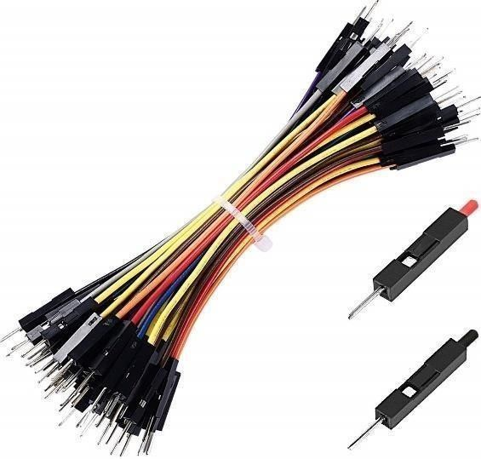

Figure 9- Jumper Wire

5.Bread Board:

A breadboard, solderless breadboard, or protoboard is a construction base used to build semipermanent [prototype](https://en.wikipedia.org/wiki/Prototype)[s of electronic circuits. Unl](https://en.wikipedia.org/wiki/Electronic_circuit)ike a [perfboard](https://en.wikipedia.org/wiki/Perfboard)  [or stripboard, bre](https://en.wikipedia.org/wiki/Stripboard)adboards do not require [soldering or](https://en.wikipedia.org/wiki/Soldering) destruction of tracks and are hence reusable. For this reason, breadboards are also popular with students and in technological education.

Compared to more permanent circuit connection methods, modern breadboards have high parasitic capacitance, relatively high resistance, and less reliable connections, which are subject to jostle and physical degradation. Signalling is limited to about 10 MHz, and not everything works properly even well below that frequency.

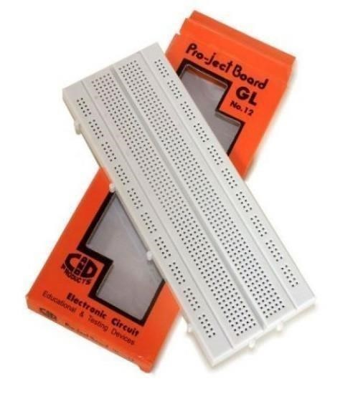

Figure 10- Bread Board

6.Ultra-Sonic Sensor:

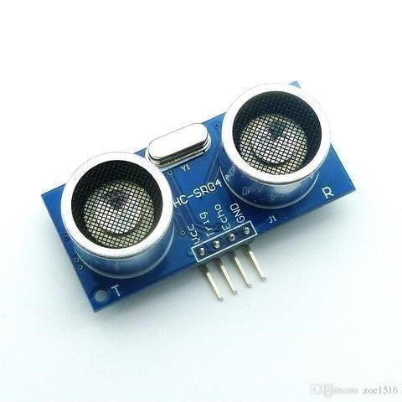An ultrasonic sensor is an electronic device that measures the distance of a target object by emitting ultrasonic sound waves and converts the reflected sound into an electrical signal. Ultrasonic waves travel faster than the speed of audible sound (i.e., the sound that humans can hear). Ultrasonic sensors have two main components: the transmitter (which emits the sound using piezoelectric crystals) and the receiver (which encounters the sound after it has travelled to and from the target). To calculate the distance between the sensor and the object, the sensor measures the time it takes between the emission of the sound by the transmitter to its contact with the receiver. Ultrasonic sensors are also used in robotic obstacle detection systems, as well as manufacturing technology. [In comparison to infrared (IR) sensors in p](https://www.maxbotix.com/articles/ultrasonic-or-infrared-sensors.htm)roximity sensing applications, ultrasonic sensors are not as susceptible to interference of smoke, gas, and other airborne particles (though the physical components are still affected by variables such as heat). Ultrasonic sensors are also used as [level sensors to d](https://www.fierceelectronics.com/sensors/what-a-level-sensor)etect, monitor, and regulate liquid levels in closed containers (such as vats in chemical factories). Most notably, ultrasonic technology has enabled the medical industry to produce images of internal organs, identify tumors, and ensure the health of babies in the womb.

Figure 11- Ultra-Sonic Sensor

7. IR Sensor:

An infrared (IR) sensor is an electronic device that measures and detects infrared radiation in its surrounding environment.IR is invisible to the human eye, as its wavelength is longer than that of visible light (though it is still on the same electromagnetic spectrum). Anything that emits heat (everything that has a temperature [above around five degrees Kelvin) giv](https://www.livescience.com/50260-infrared-radiation.html)es off infrared radiation.

There are two types of infrared sensors: active and passive. Active infrared sensors both emit and detect infrared radiation. Active IR sensors have two parts: a light emitting diode (LED) and a receiver. When an object comes close to the sensor, the infrared light from the LED reflects off the object and is detected by the receiver. Active IR sensors act as [proximity sensors, and](https://www.fierceelectronics.com/sensors/what-a-proximity-sensor) they are commonly used in obstacle detection systems (such as in robots).

Passive infrared (PIR) sensors only detect infrared radiation and do not emit it from an LED.

PIR sensors are most used in motion-based detection, such as in-home security systems. When a moving object that generates infrared radiation enters the sensing range of the detector, the difference in IR levels between the two pyroelectric elements is measured. The sensor then sends an electronic signal to an [embedded computer, whi](https://www.fierceelectronics.com/embedded/what-embedded-computer)ch in turn triggers an alarm.

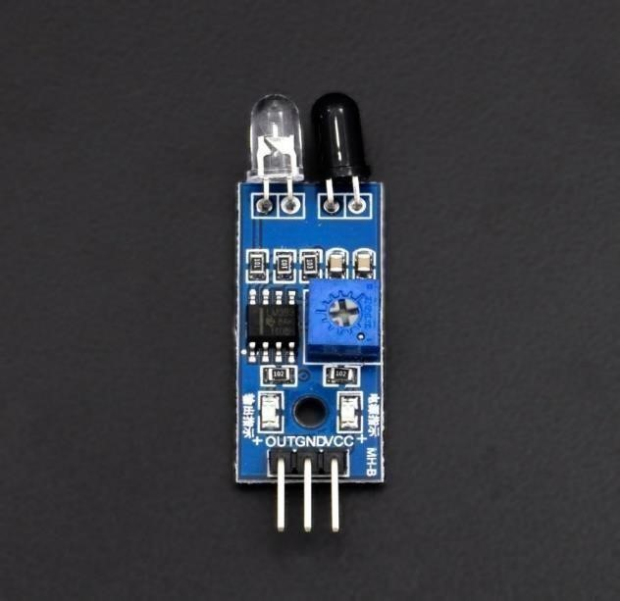

Figure 12- IR Sensor

8. I2C Module:

I2C is short for Inter-IC. And it is a type of BUS. This is designed by Philips semiconductors.

I2C is a synchronous, multi slave, multi master packet switched, single-ended serial bus.

For more about I2C protocol, it is also known as I2C Module. It has total of 20 male pins.

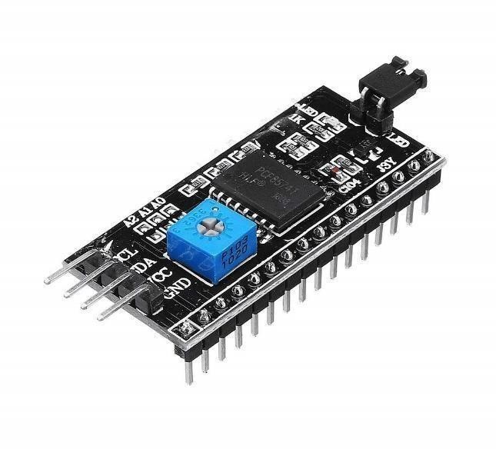16 pins are faced to rear side and 4 pins faced towards front side. The 16 pins for connect to 16x2 LCD and the 2 pins out of 4 pins are SDA and SCL. SDA is the serial data pin and SCL is the clock pin.

Figure 13- I2C Module

9.Potentiometer:

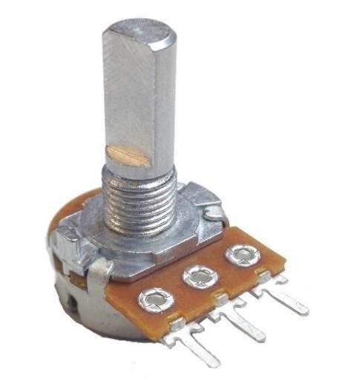A potentiometer is a three[-term](https://en.wikipedia.org/wiki/Terminal_(electronics))[inal resistor with](https://en.wikipedia.org/wiki/Resistor) a sliding or rotating contact that forms an adjustable [voltage divider. If](https://en.wikipedia.org/wiki/Voltage_divider) only two terminals are used, one end and the wiper, it acts as a variable resistor or rheostat. Potentiometers are commonly used to control electrical devices such as volume controls on audio equipment. Potentiometers operated by a mechanism can be used as position [transducers, pot](https://en.wikipedia.org/wiki/Transducer)entiometers consist of a [resistive element, a s](https://en.wikipedia.org/wiki/Electrical_resistivity_and_conductivity)liding contact (wiper) that moves along the element, making good electrical contact with one part of it, electrical terminals at each end of the element, a mechanism that moves the wiper from one end to the other, and a housing containing the element and wiper.

Figure 14- Potentiometer

10.Node MCU:

NodeMCU is a low-cost open source [IoT plat](https://en.wikipedia.org/wiki/Internet_of_Things)form. It initially included [firmware whic](https://en.wikipedia.org/wiki/Firmware)h runs on the [ESP](https://en.wikipedia.org/wiki/ESP8266)[8266 W](https://en.wikipedia.org/wiki/Wi-Fi)[i-Fi SoC fr](https://en.wikipedia.org/wiki/System_on_a_chip)[om Espressif Syst](https://en.wikipedia.org/w/index.php?title=Espressif&action=edit&redlink=1)ems, and hardware which was based on the ESP-12 module. Later, support for the [ESP32 32-b](https://en.wikipedia.org/wiki/ESP32)it MCU was added. NodeMCU is an opensource firmware for which open source [prototyping boar](https://en.wikipedia.org/wiki/Prototyping)d designs are available. The name "NodeMCU" combines "[node" and](https://en.wikipedia.org/wiki/Node_(computer_science)) "MCU" ([micro-controller unit](https://en.wikipedia.org/wiki/Micro-controller)). Strictly speaking, the term "NodeMCU" refers to the firmware rather than the associated [development kits.](https://en.wikipedia.org/wiki/Development_kits)

Both the firmware and prototyping board designs are [open source.](https://en.wikipedia.org/wiki/Open_source)

The firmware uses the [Lua scri](https://en.wikipedia.org/wiki/Lua_(programming_language))pting language. The firmware is based on the eLua project, and built on the Espressif Non-OS SDK for ESP8266. It uses many open source projects, such as lua-cjso and [SPIFFS. Due](https://en.wikipedia.org/w/index.php?title=SPIFFS&action=edit&redlink=1) to resource constraints, users need to select the modules relevant for their project and build a firmware tailored to their needs. Support for the 32-bit [ESP32 has](https://en.wikipedia.org/wiki/ESP32) also been implemented.

There are two available versions of NodeMCU as version 0.9 & 1.0 where the version 0.9 contains ESP-12 and version 1.0 contains ESP-12E where E stands for "Enhanced".

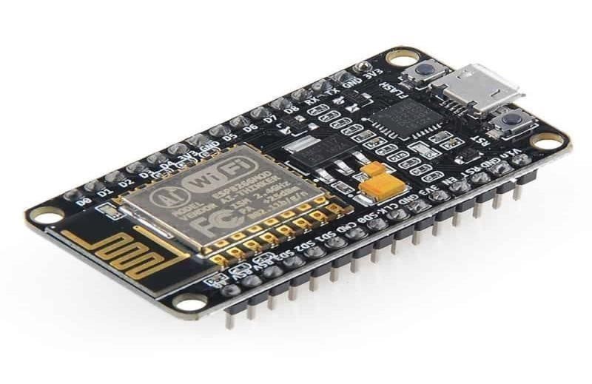

*Fig 2.15 Node MCU*

11. Arduino UNO:

Arduino UNO is based on Microchip [ATmega328P micr](https://en.wikipedia.org/wiki/ATmega328P)ocontroller and developed by [Arduino.cc and](https://en.wikipedia.org/wiki/Arduino) initially released in 2010. The board is equipped with sets of digital and analog [input/output (I/O](https://en.wikipedia.org/wiki/Input/output)) pins that may be interfaced to various [expansion boards (shi](https://en.wikipedia.org/wiki/Expansion_board)elds) and other circuits. The board has 14 digital I/O pins (six capable of [PWM outp](https://en.wikipedia.org/wiki/Pulse-width_modulation)ut), 6 analog I/O pins, and is programmable with the [Arduino IDE (Int](https://en.wikipedia.org/wiki/Arduino#Software)egrated Development Environment), via a type B [USB cable. It](https://en.wikipedia.org/wiki/USB_cable) can be powered by the USB cable or by an external [9-volt battery, tho](https://en.wikipedia.org/wiki/9-volt_battery)ugh it accepts voltages between 7 and 20 volts.

The word "[uno" mea](https://en.wiktionary.org/wiki/uno)ns "one" in [Italian and](https://en.wikipedia.org/wiki/Italian_language) was chosen to mark the initial release of [Arduino Software. The](https://en.wikipedia.org/wiki/Arduino_Software) Uno board is the first in a series of USB-based Arduino boards, it and version 1.0 of the Arduino [IDE were](https://en.wikipedia.org/wiki/Integrated_development_environment) the reference versions of Arduino, which have now evolved to newer releases. The ATmega328 on the board comes preprogramed with a [bootloader that](https://en.wikipedia.org/wiki/Bootloader) allows uploading new code to it without the use of an external hardware programmer.

While the Uno communicates using the original STK500 protocol, it differs from all preceding boards in that it does not use the FTDI USB-to-serial driver chip. Instead, it uses the Atmega16U2 (Atmega8U2 up to version R2) programmed as a [USB-to-serial converter.](https://en.wikipedia.org/wiki/USB-to-serial_converter)

General pin functions

LED: There is a built-in LED driven by digital pin 13. When the pin is high value, the LED is on, when the pin is low, it is off.

VIN: The input voltage to the Arduino/Genuino board when it is using an external power source (as opposed to 5 volts from the USB connection or other regulated power source). You can supply voltage through this pin, or, if supplying voltage via the power jack, access it through this pin.

5V: This pin outputs a regulated 5V from the regulator on the board. The board can be supplied with power either from the DC power jack (7 - 20V), the USB connector (5V), or the VIN pin of the board (7-20V). Supplying voltage via the 5V or 3.3V pins bypasses the regulator, and can damage the board.

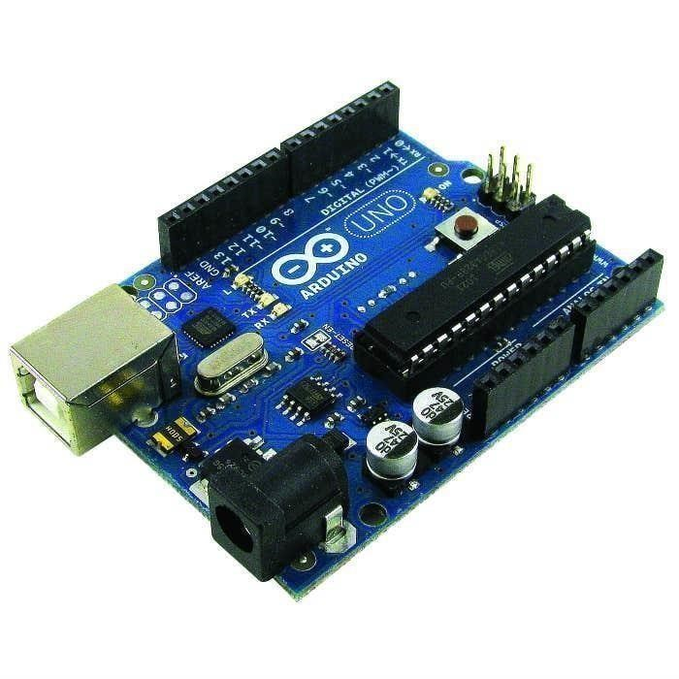3V3: A 3.3-volt supply generated by the on-board regulator. Maximum current draw is 50 mA. GND: Ground pins.

*Fig 2.16 Arduino UNO*

12. Raspberry PI:

Raspberry Pi is a series of single-board computers designed for education and hobbyist projects. It was created by the Raspberry Pi Foundation in the United Kingdom and has gained a massive following worldwide.

The Raspberry Pi boards are small, affordable, and capable of running various operating systems, including Linux and Windows 10. They have a broad range of applications, including home automation, media centers, retro gaming, robotics, and more.

The latest Raspberry Pi models feature impressive hardware specifications, such as a powerful CPU, plenty of RAM, and high-speed connectivity options like Wi-Fi and Bluetooth. The boards also have a variety of input/output (I/O) interfaces, making them easy to connect to other devices and sensors.

Raspberry Pi has become a popular tool for teaching coding and electronics to students and enthusiasts of all ages. Its versatility and affordability have made it a go-to choice for DIY projects and prototyping. Raspberry Pi's extensive community provides plenty of resources, including tutorials, projects, and forums, making it a great platform for learning and experimentation.

There are currently several models of Raspberry Pi, each with different specifications and capabilities. Here is an overview of the models as of my knowledge cutoff date of 2021-09:

Raspberry Pi 4 Model B: This is the latest and most powerful model of Raspberry Pi, released in 2019. It has a quad-core ARM Cortex-A72 CPU, up to 8GB of RAM, and supports dual 4K displays. It also has USB 3.0 and Gigabit Ethernet for faster data transfer.

Raspberry Pi 3 Model B+: This model was released in 2018 and is still popular today. It has a quad-core ARM Cortex-A53 CPU, 1GB of RAM, and support for wireless networking via built-in Wi-Fi and Bluetooth.

Raspberry Pi 3 Model A+: This is a smaller and more affordable version of the Raspberry Pi 3 Model B+, with the same CPU and RAM but without Ethernet or USB ports.

Raspberry Pi Zero W: This is the smallest and cheapest model of Raspberry Pi, with a single-core ARM11 CPU, 512MB of RAM, and built-in Wi-Fi and Bluetooth. It is designed for use in small, portable projects where space and cost are important factors.

There are also older models of Raspberry Pi, such as the Raspberry Pi 2 and the original Raspberry Pi, but these are less commonly used today due to their lower specifications.

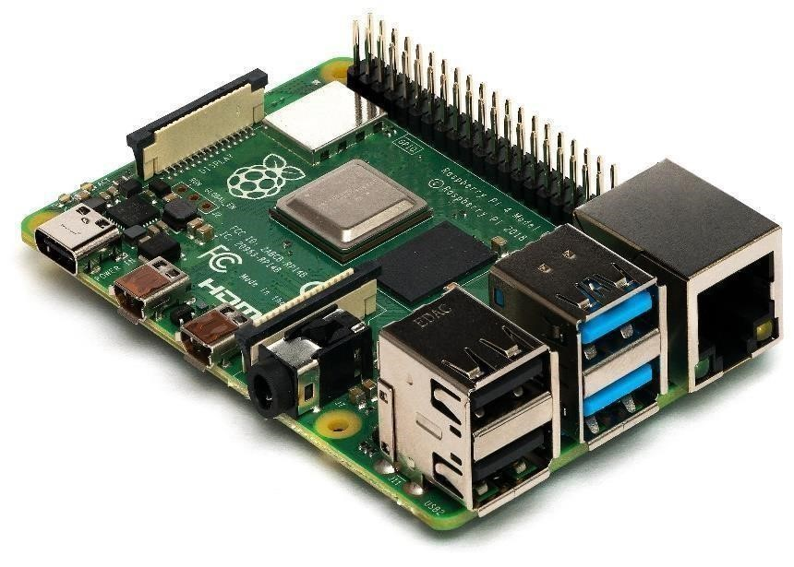

Figure 15- Raspberry Pi

## CHAPTER 3

## LEARNING OUTCOMES

This course will teach you about current microcontrollers, application development, and product and prototype design. This course is ideal for engineering students and graduates with a basic understanding of electronics and microprocessors. The Internet of Things (IOT) is the world's next big thing. We live in the Internet of Things era (mobile phones, computers, etc.), and the future will be connected to the Internet of Things (e.g., home appliances, automobiles, street lighting, personal accessories, pets, industrial equipment, etc.).

The phrase "Internet of Things" refers to connecting things to the Internet and linking things to each other so that people and things may evaluate data from numerous sources in real time and behave intelligently, such as home appliances, automobiles, street lighting, and personal accessories.

The Internet of Things refers to the process of connecting things to the Internet and linking things to each other so that people and things may evaluate data from numerous sources in real time and act intelligently.

Embedded systems are at the heart of many goods, machinery, and intelligent activities. B. Applications in machine learning and artificial intelligence. With embedded system applications appearing in every industry and sector today, embedded devices and software play a critical part in the performance of autos, consumer electronics, medical devices, interactive kiosks, and other things we use in our everyday lives. plays.

Real embedded systems, which are increasingly becoming a part of our daily lives, are meant to work with minimum human interaction. Compact size, simple design.

During my training, I studied the fundamentals of the Python programming language. Guido van Rossum created Python, as well as what it is and who created it. The first film was released in 1991. It is commonly used in the construction of websites and software, task automation, data analysis, and data visualisation. Because it is rather simple to grasp. Python syntax is as straightforward as English syntax. You may execute your code as soon as you finish writing it. Python may be used in online apps, gaming apps, enterprise-level applications, machine learning apps, image processing, word processing, and other applications. How to use the if statement in Python: how to print, how to initialise variables, how to convert one data type to another, and how to determine the type of variables.

• A list is an organised and changing collection. Allows for multiple members.

• A tuple is an ordered and immutable collection. Allows for multiple members.

• A set is an unordered, immutable, and unindexed collection. There are no duplicate members.

A dictionary is a well-organized and ever-changing collection of words. There are no members who are duplicates. I now understand what a list is, how to make one, how to access and alter list items, how to add and delete things from a list, and how to arrange list items. I learned about tuples, including what a tuple is, how to build a tuple, and how to retrieve a tuple's contents. Following that, we'll go into functions, covering how to call them, build them, and more. I created a software that outputs only even integers and a basic calculator application that does addition, subtraction, multiplication, and division using functions and arithmetic. operator.

Dictionary element values can be of any data type, and dictionaries are defined as objects of data type dict. You also learned how to manage Python files. The main function for working with files in Python is the open() function. The function () contains two operands. File name and format.

There are four different methods (modes) for opening a file:

"r" - Read - Default value. Opens a file for reading, error if the file does not exist.

"a" - Append - Opens a file for appending, creates the file if it does not exist.

"w" - Write - Opens a file for writing, creates the file if it does not exist. "x"

- Create - Creates the specified file, returns an error if the file exists.

I wrote a programme that takes n user inputs and outputs the sum and average of all the numbers using a while loop, and another programme that takes n inputs and separates the even and odd numbers, then adds the evens and odds separately, giving the sum of even and odd numbers printed in two separate files.

I've learnt about tinker cad, and the circuit is created using it. We first made a basic circuit to power the LEDs, then we tried connecting the three LEDs in series and parallel, then we connected the DC motor using a circuit consisting of a potentiometer and a battery, and we can control the speed of the motor using the potentiometer.

We created a half-wave rectifier circuit with diodes and a signal generator, and we can see the output on the oscilloscope. We also created a full-wave rectifier circuit and examined the output. We also learnt what an Arduino board is and what varieties of Arduino boards may be used to make circuits, as well as how to install a software called Arduino Ide, which allows us to write programmes to "Embedded system based on IOT" Dept. of ECE 2020-2021 Page-19 Convert a high-level language to a machine language for usage on the Arduino board. We learnt how to use the programme to light the inbuilt LED in Arduino, and we built a circuit as well as a software that controls the bulb using a switch.

They taught us what the humidity sensors are, how they work, we connected the humidity sensors to the Arduino and the LCD shows the value of the humidity level of our surrounding environment.

Finally, we built a circuit that connects the LDR and LED to the Arduino. An LDR sensor detects the presence of ambient light, causing streetlights to switch off automatically throughout the day when the sun is shining brightly. When there is no light at night, the LDR sends a signal to the microcontroller, instructing it to turn on the streetlights.

I basically brush up on the Python language and experiment with new topics like python classes and how to construct them, as well as python inheritance, of which there are two classes. The parent class is the class that is being inherited from, also known as the base class, and the child class is the class that inherits from another class, also known as the derived class.

I experiment with new projects in Tinker Cad, such as solar tracking, which includes of a potentiometer, servo motor, breadboard, photo resistors, a solar panel, and an Arduino. This is a technology that uses light-sensitive resistors to detect sunshine and guides solar panels to move accordingly in order to enhance efficiency. To enhance or reduce the sensitivity of the light-sensitive resistor, two potentiometers are employed. Potentiometers can also be utilised to control the servo motors instead.

The automatic room lighting system is made up of a PIR sensor, a relay, a bulb, an Arduino, and photo resistors. This self-contained room lighting system works in the same way as commercial motion sensor lighting systems. It basically detects movement with a motion sensor and briefly turns on the associated lights. When this time period is completed, we will have learned what an ultrasonic sensor is and how ultrasonic sensors are used to detect distance and obstructions in front of an item. The ultrasonic sensor has four pins for power, GND, trigger input, and echo output. We created a circuit and code that includes an ultrasonic sensor, a speaker, an LCD display, and an Arduino to detect things.

We learned what a servo motor is, what it is used for, and how it operates. A servo motor has three pins: power, ground, and signal. We created a circuit using a PIR sensor, a servo motor, and an Arduino. When a human passes in front of the PIR sensor, the servo motor begins to rotate. These circuits are employed in automated doors, checkpoints, and other applications. We may also regulate the rotational angle of the blades. The benefit of a servo motor is that it remembers its initial position, so if we want to turn it by a given angle, it will rotate with regard to its initial position. Finally, we installed some raspberry pie-related applications.

We wrote a code which blinks the led which is connect to node MCU, and then we uploaded the code to node MCU, we constructed the circuit so that LED starts blinking, and we also connected buzzer also.

We learnt what is IR and ultrasonic sensor how the IR sensors and ultrasonic sensors are used, when IR sensor is connected to node MCU, in IR sensor there are two parts transmitter and receiver. If there is No obstacles in between transmitter and receiver that current starts flowing in the circuit, if buzzer is connected it makes sound.

We connected ultrasonic sensor to node MCU. In ultrasonic sensors it will produce sound waves, if there is any object in front of ultrasonic sensor than the sound waves will hit back to the sensor so from the duration, we can determine the distance between the object and the sensor. We connected buzzer to ultrasonic sensor, and we applied the condition so that if the distance is less than few centimetres than buzzer starts making sounds.

IR sensor consists of four pins, analog output, digital output, power, and GND. Ultrasonic sensor also consists of four pins, power, GND, trigger output and echo input.

We built a circuit which consists of ultrasonic sensors, buzzer, Node MCU, LED. We wrote a code and uploaded to MCU. Ultrasonic sensor will measure the distances using duration and we gave a condition if distance is greater than 50cm than LED and buzzer will be off. When the distance is less than 50cm than LED will glow and then buzzer will be turned on.

We built a circuit in which LCD is connected to the node MCU, which consists of buzzer. We wrote a code and then uploaded to the MCU. We wrote a condition like if the distance is greater than 30cm than buzzer will be turned off, LCD will display "u can move". When the distance is less than 30 and more than 20cm than buzzer will make sound with high frequency and then LCD will display "object is near, please go slow". When the distance is less than 20cm than buzzer will make sound with high frequency and then LCD will display "please stop".

The above circuit can be used in cars, water level indicators etc.

We learned what a DHT sensor is and how to use it to measure both temperature and humidity. First, we connected the DGT sensor to the node MCU and uploaded the code via USB. A serial monitor prints the room temperature and humidity levels to the screen. Node MCU has an IC called Wi-Fi module, from which data can be sent to the cloud. We use a separate chip for the WIFI module as it does not exist on the Arduino. First, you need to login to the Things Peak website with your MATLAB account, create a channel, and then upload your code to your MCU node. The code should describe the SSID, password and API pin. Once the code is uploaded, the DHT sensor will start measuring the room's temperature and humidity and start displaying them on the website. The temperature and humidity readings will be uploaded every second

I learned how to create channels, generate API pins, and use the WIFI module to send data to the cloud. The channel consists of 8 fields, so you can measure temperature, humidity, climate, etc. at the same time. On his website for Things Peak, values are displayed using graphical representations so that users can better understand them.

I learned what Raspberry Pi boards are and how to use these boards in your projects. I installed the software Putti, VNC Server and BALENA Etcher. I used BALENA Etcher to transfer the .img file to a micro SD card and inserted it into the Raspberry Pi board. After that I connected the ethernet cable to the raspberry pi and the USB for power. Then I used the command ping 169.254.0.5 in CMD prompt to check the status of the raspberry pi. Then open putti and open it with your IP address. It then asked for the username pi, asked for the password Raspberry, and started writing code on the screen. You can also control the Raspberry Pi without a laptop, so you'll need an external keyboard, mouse, display, and power supply. Running the ls command shows all the folders available on the raspberry pi. After running the VNC server command, the laptop display shows all the applications, folders, and data available on the Raspberry Pi.

I was exploring new projects using node MCU and Arduino. We used to build a circuit and start simulation using tinker cad and I was thinking about the home automation system project using Arduino so I built a circuit consists of gas sensor which is used to detect the amount of poisonous gas with in the house, ultrasonic sensor it is used to detect the distance between the person and the door, photo resistors when the light falls on the photo resistors then it's resistance increase so in the day time bulb will not glow, Arduino board is a main in which all the components are connected, power supply, bulb, motor, lcd display to display the values of gas sensor, ultrasonic sensor, condition of the bulb.

I wrote a code with the help of Google. And then it starts simulation, and it was working fine. If there is any poisonous gas present inside the house, then gas sensor detects and will display the instructions and level of poisonous. Ultrasonic sensor will display the distance so that we can if there is any person is front of door. PIR sensor, when anyone come in the range then bulb will glow automatically, but in the day time bulb will be off because of photo resistors.

I explore some Arduino projects in tinker cad. Password access control system consists of bulb, keypad, lcd, NPN transistor, resistor, power supply and Arduino. This circuit is useful for doors, lockers etc. First, the LCD display prompts the user to enter a four-digit password via the keypad module. the first-time password is “1234”. Once the system has been unlocked, the message “UNLOCKED” will be shown on the LCD display. The light bulb controlled with the Arduino and relay will also light up.

Room temperature control system consists of temperature sensor, potentiometer, motor, NPN transistor, led and Arduino. This project is an automatic room temperature system that maintains the temperature between 20 and 25 °C. When the temperature dips below the minimum threshold, feedback is displayed on the LCD screen. It then activates the heater to turn on, warming up the temperature in the room. Once the temperature is back within the 20 to 25 °C range, it commands the heater to turn off. On the flip side, if the temperature goes too high, the LCD screen display changes and the system commands the fan to turn on. Once the temperature is back within the target range, the fan is automatically turned off.

I'm investigating other projects at Tinker Cad. Fire alarm system consisting of temperature sensor, gas sensor, buzzer and Arduino. As the temperature increases, so does the voltage. 10 mV per degree. This output beeps. Gas sensors not only detect the presence of smoke, but also measure gas concentrations. The user specifies the conditions in the project code that determine the measurement thresholds at which the LED is turned on or off. CPR feedback devices are an important life-saving skill and require practice to perfect. It uses simple components such as LEDs and 16x2 LCD screens to provide visual feedback. These relate to breadboards, alligator clips, and cheap jumper wires, as well as other components. After all, the "brain" of the project is the Arduino Uno.

When the chest is pressed to the correct required depth, the push button is activated and the LED turns green. On the other hand, if the correct depth has not been reached, the LED will turn red instead. In addition, pressure sensitive resistors are placed on the doll's chest to detect the pressure being applied.

I was looking into other Arduino projects on Tinker Cad. A two-way visitor counter consisting of a buzzer, LCD display, ultrasonic sensor, and Arduino. This project counts the number of visitors entering a place from two directions. I am using an ultrasonic distance sensor, specifically the HC-SR04 module. As feedback, a 16x2 LCD screen displays the number of visitors. In addition, a buzzer sounds when a visitor enters the range. Several variations of this system are used in real applications. For example, retail stores use it to assess the effectiveness of marketing campaigns, building design and layout, and the popularity of certain brands. Pet Feeder This is an automatic pet feeder made with Arduino Uno. This simple setup uses a push button switch to control the lid of a food container connected to a servo motor. To control the amount of feed dispensed, the user simply controls the servo. Other parts needed for this build are an LED, wires and a current limiting resistor.

I explored node MCU based projects. Energy efficient and voice controllable LED, it consists of led, node MCU, H bridge motor drivers. Firstly, sensor data on the environment’s illuminance is collected by the (1) microcontroller. Then, the sensor’s reading will be sent to Arduino IoT cloud - a cloud-based platform for IoT applications - by an Internet connection via WIFI. The microcontroller’s role is to control the brightness of the LED generating the PWM signal. The microcontroller can be controlled in 2 scenarios:

By the control panel on the dashboard of Arduino IoT cloud on either the website or the application on the smartphone and by voice command through Alexa.

# CHAPTER 4

## CONTRIBUTIONS WITH RESULTS AND DISCUSSIONS

Many times we need to monitor the person/people visiting someplace like Seminar hall, conference room or Shopping mall or temple. This project can be used to count and display the number of visitors entering inside any conference room or seminar hall. This is a unidirectional counter which means it works in a single way. That means a counter will be incremented if a person enters the room. LCD displays this value which is placed outside the room.

This system is helpful for counting the number of people in an auditorium or halls for seminar. Moreover, it can also be used to check the number of people who have come to an event or a museum to watch a certain exhibit.

I have used a two PIR sensor for bi-directional visitor counter. Within 40 cm range, it will count how many visitors enter the room on a particular day. Whenever a person enters a room the buzzer will beep and there will be an increment in the integer I to show the number of persons.

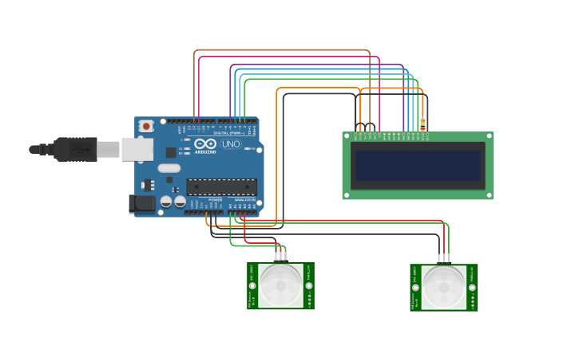We built a circuit called a bi-directional visitor counter.It consists of an ultrasonic sensor that measures the number of entered from the door, a PIR sensor that detects a person when he enters the house . It has an LCD screen that shows all the functions of the sensors and the Arduino UNO is the main board where all the components are connected.

*Fig 2.18 Bi-Directional Visitor Counter*

# CHAPTER 5

## SUMMARY

IOT is concerned with the development of intelligent devices that facilitate various tasks for humans. Smart devices are created with embedded systems. Embedded systems are minicomputers that allow sensor devices to work together to create electronic systems.

It can be said that embedded systems can be used to create intelligent systems that can perform numerous tasks with the help of attached sensors. In this study, we examined the most popular embedded systems that can be used to easily and efficiently create various electrical circuits. The Internet of Things is the concept of connecting devices over the Internet to exchange data. It is the hottest technology in this modern world as it allows you to control your embedded devices from anywhere through the Internet of Things.

In summary, the Internet of Things (IoT) equips objects with sensors, actuators, and processors, including the design and development of hardware boards, software systems, web APIs, and protocols that together create a connected, embedded environment system.

A connected environment enables technology to connect multiple devices, platforms, and networks. This creates a communications network that will change the way we interact digitally with the world. These connected and embedded systems can change how we behave towards our environment, community and home. When it comes to designing embedded IoT systems, they need to be designed for specific functions while considering factors such as low power consumption, secure architectures, and reliable processors. However, designing embedded IoT hardware systems is difficult.

# CHAPTER 6

## REFERENCES

1. <https://docs.arduino.cc/hardware/uno-rev3>
2. <https://en.wikipedia.org/wiki/Raspberry_Pi>
3. <https://en.wikipedia.org/wiki/NodeMCU>
4. <https://en.wikipedia.org/wiki/Embedded_system>
5. <https://en.wikipedia.org/wiki/Internet_of_things>